USER MANUAL

The stakeholders involved in the seed chain involves:

=> Seed Grower/ Farmer

=> Seed Producing Agency

=> Seed Testing Lab

=> Seed Certification Agency

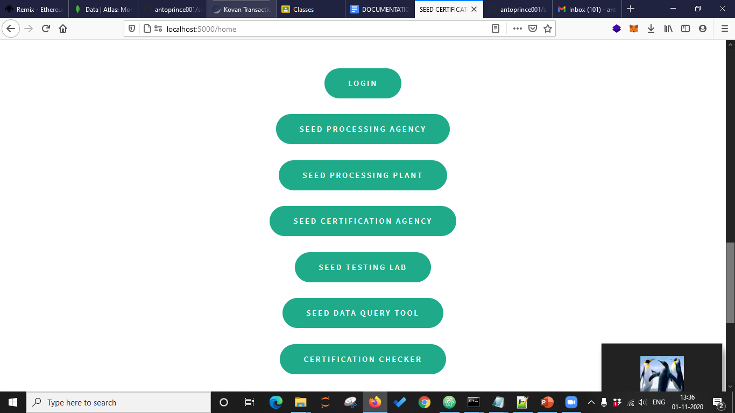

Login:

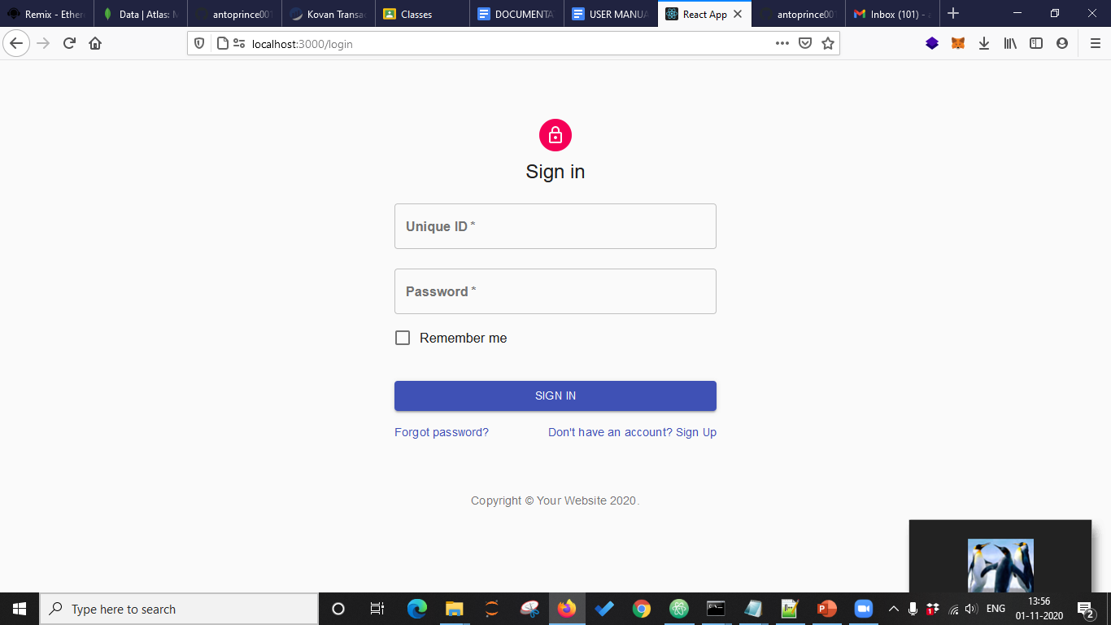

Seed Grower:

The seed grower(SG) will be provided the login who will be able to view information such as seed lot, the variety and type of the seed, grower name, year, season and several other details. He will be able to view the details of a Seed Lot/Tag. The details about the seed lot will be provided in a PDF format.

Seed Producing Agency (SPA)

SPA will be provided with the login where he can add details fetched from the Seed Processing Plant (SPP) and the seed Grower. SPA will be handy enough with the following information such as Lot Number, source store house, destination store house, sgName, sgId and other related fields.

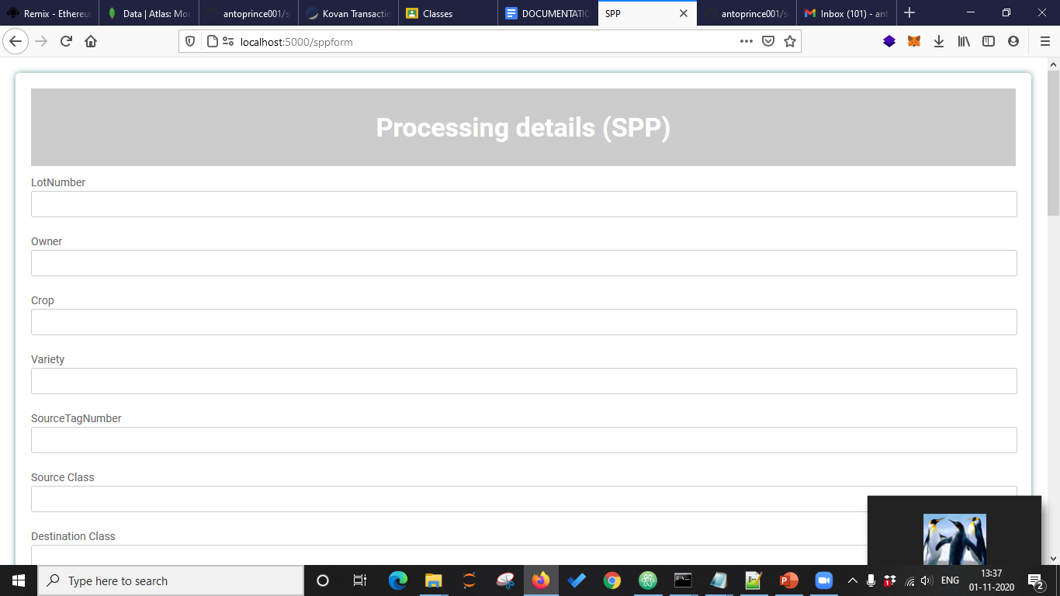

Seed Certification Agency(SCA)

The SCA will be provided with a login where he can update the details of the seed by the unique lot number associated with it. The provision of PDF reader enables the SCA to upload the pdf from wherein the data is extracted and uploaded directly to the block.

After the seed processing phase, the SCA will update the following:

TotalQuantityProcessed

processingDate

verificationDate

SampleSecreteCode

Once the seed testing is done, he will upload the following certification details.

CertificateNo

CertificateDate

CertificateValidityInMonth

Once the verification is done, he will be able to add in the following details

The tag series code, Range issued from and to, the total number of tags issued.

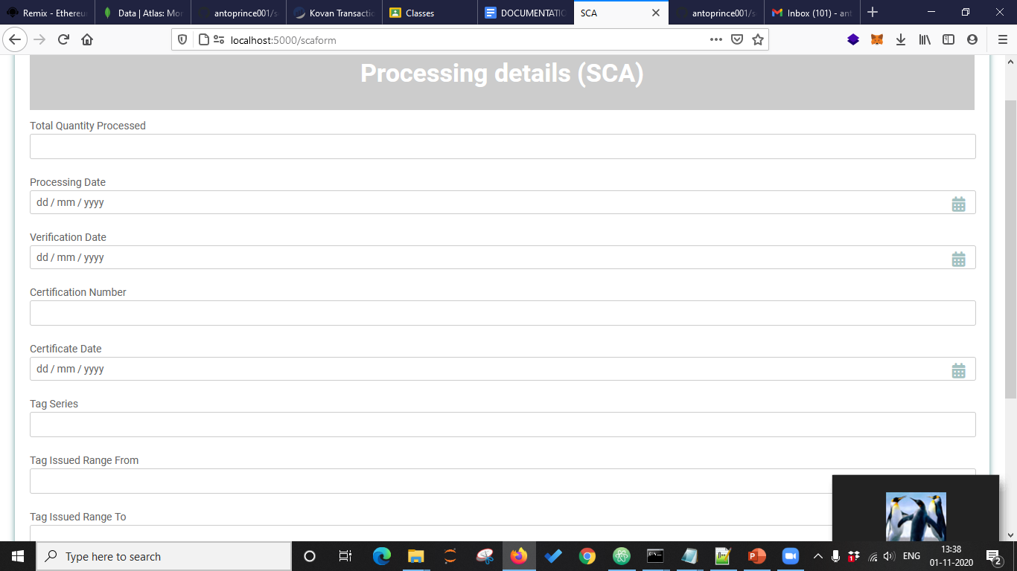

Seed Testing Lab (STL):

Update the test results against the secret code of the sample in the block.

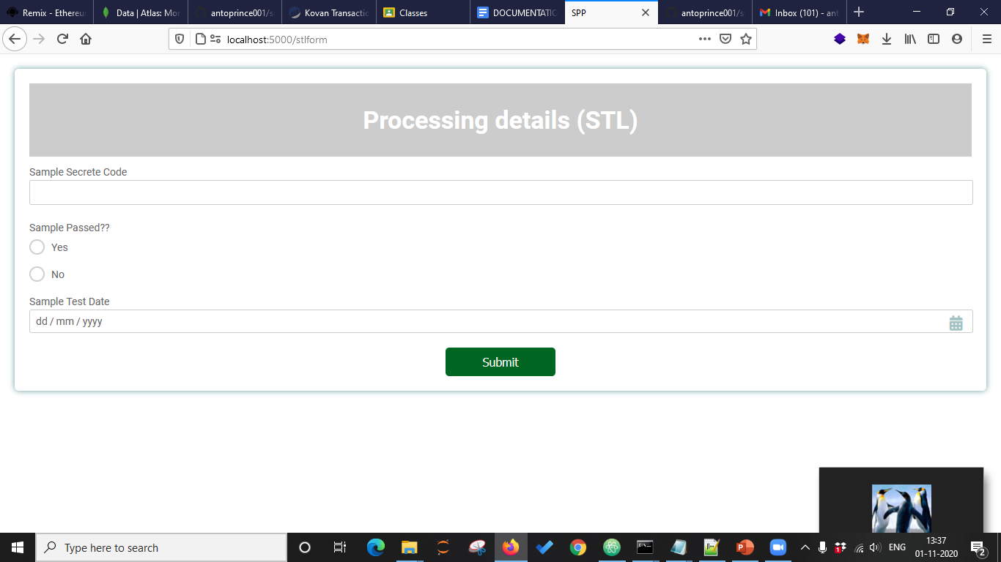

Data Query Tool

Provides the data in json format for corresponding LotNumber or SourceTagNo

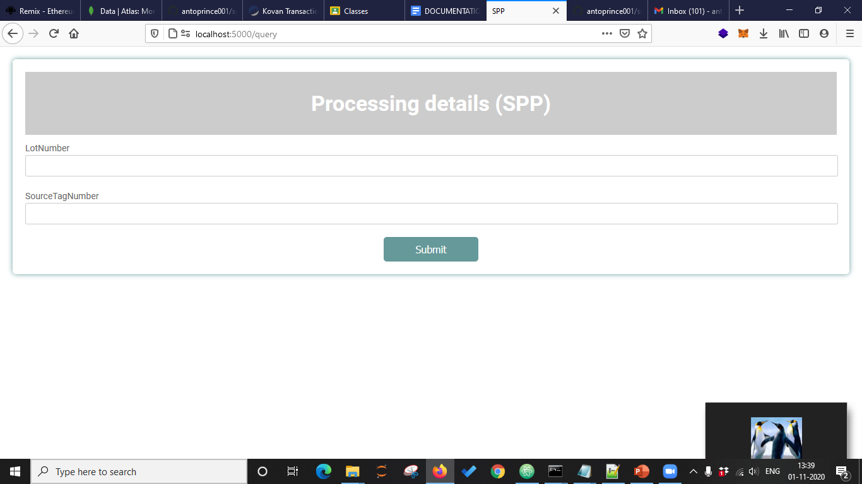

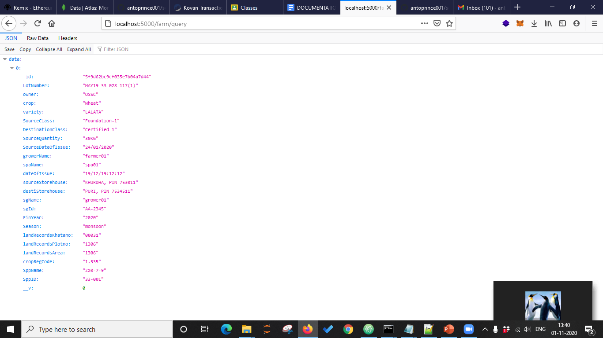

Certification Checker

For a particular LotNumber or SourceTagNumber, returns the certificate status in local language.

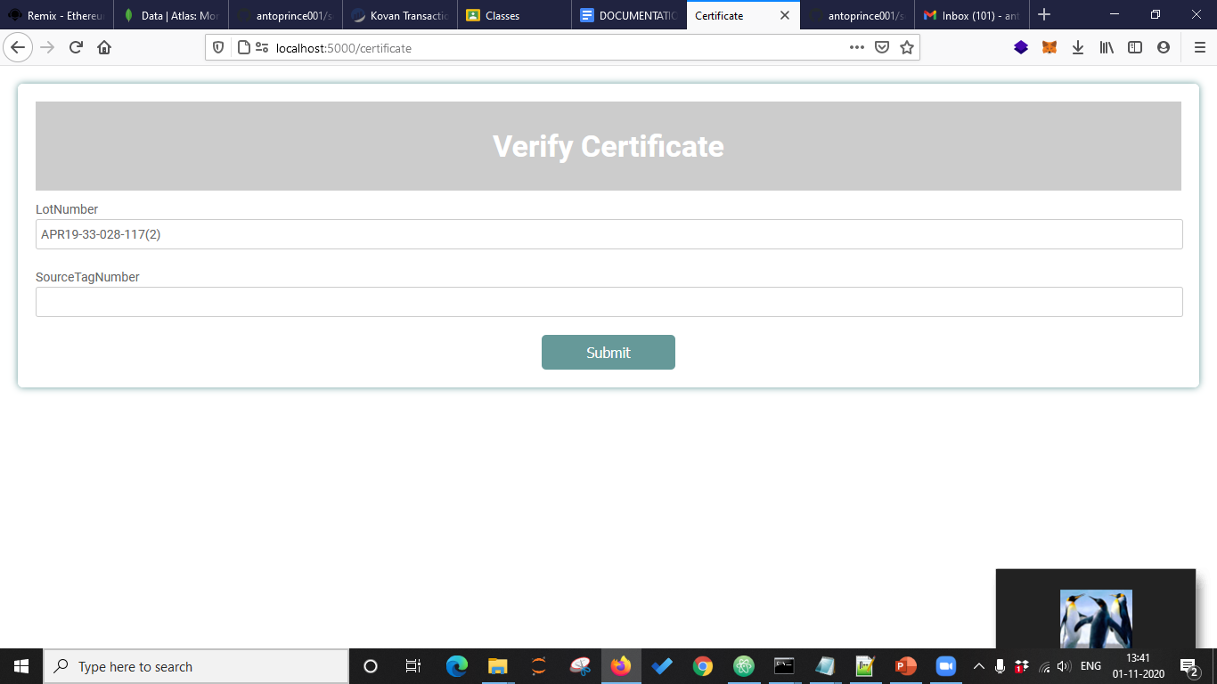

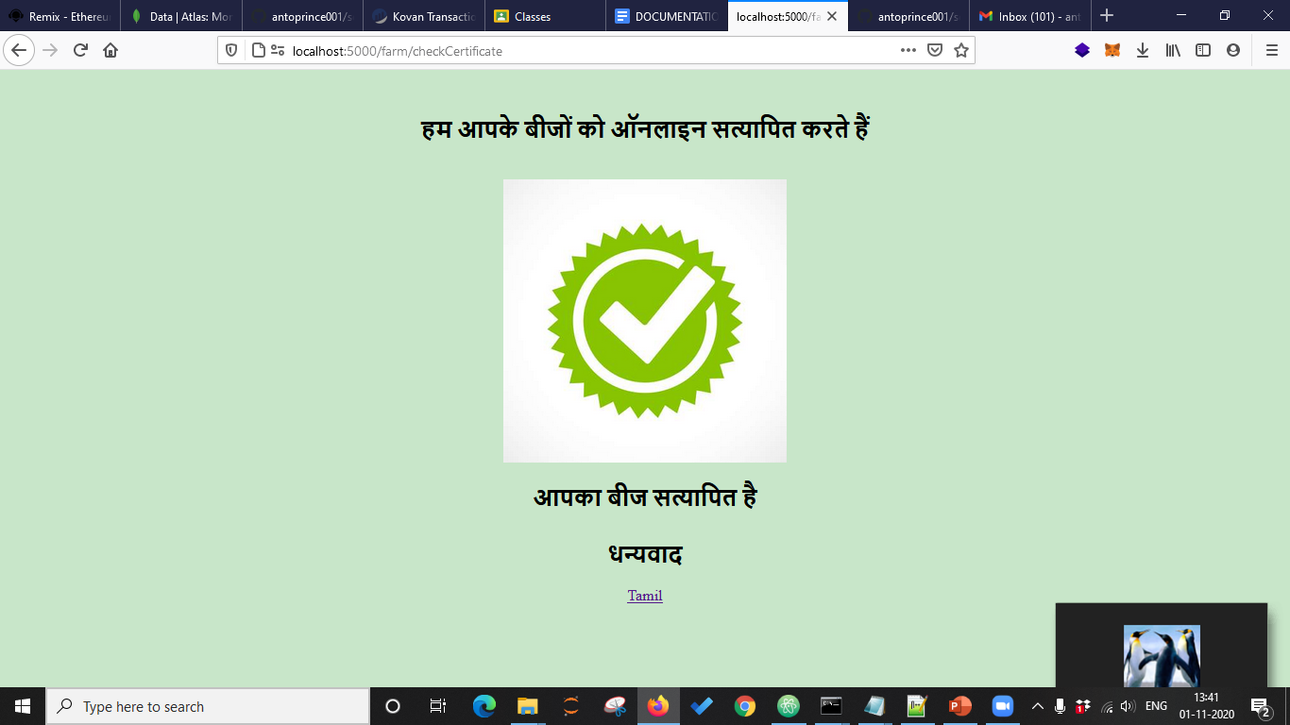

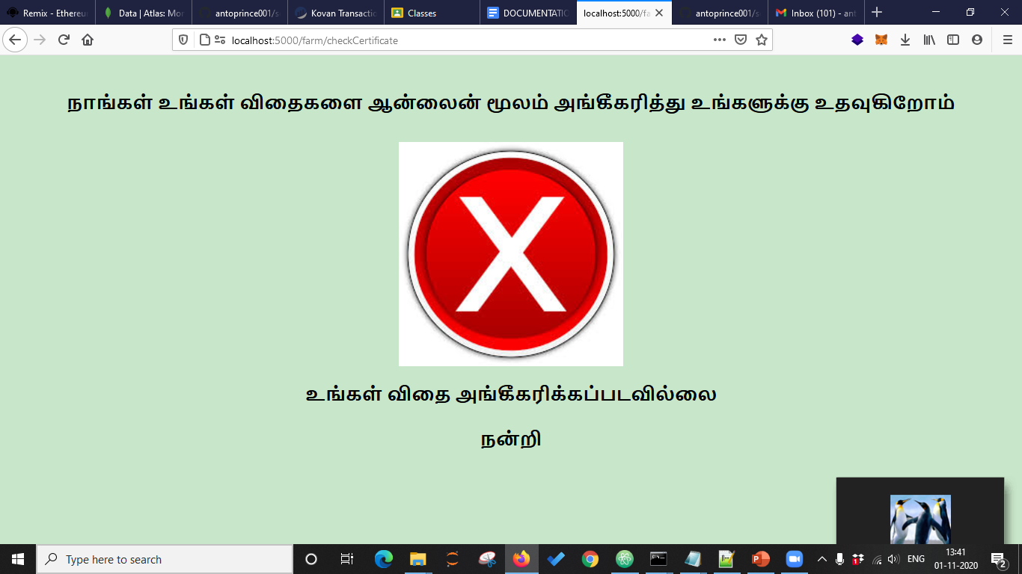

Analytics Tools

SCA Dashboard

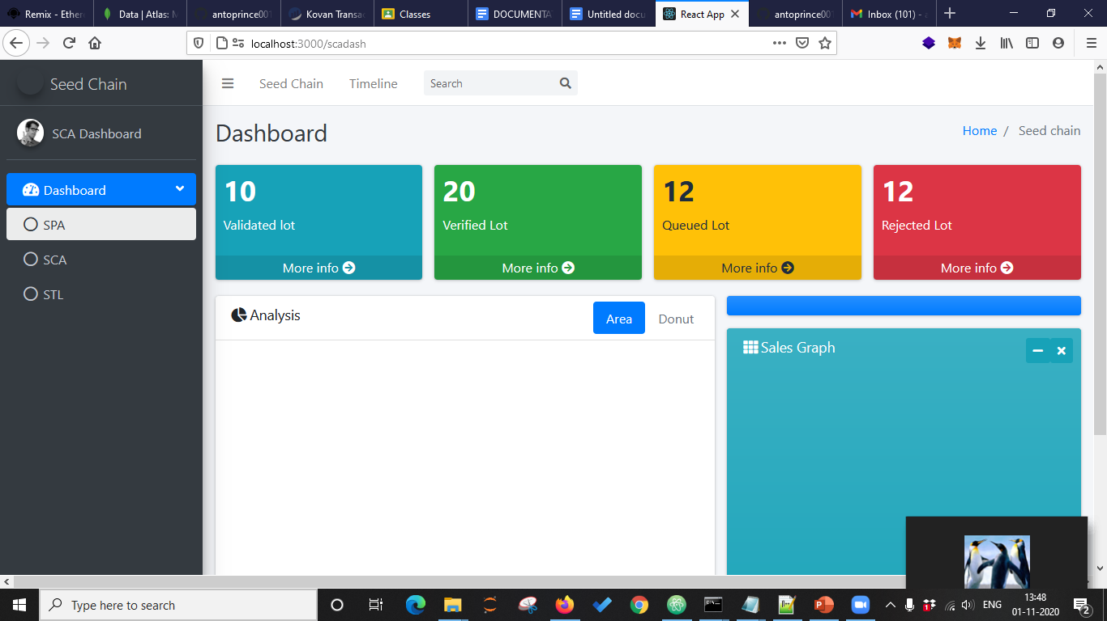

STL dashboard

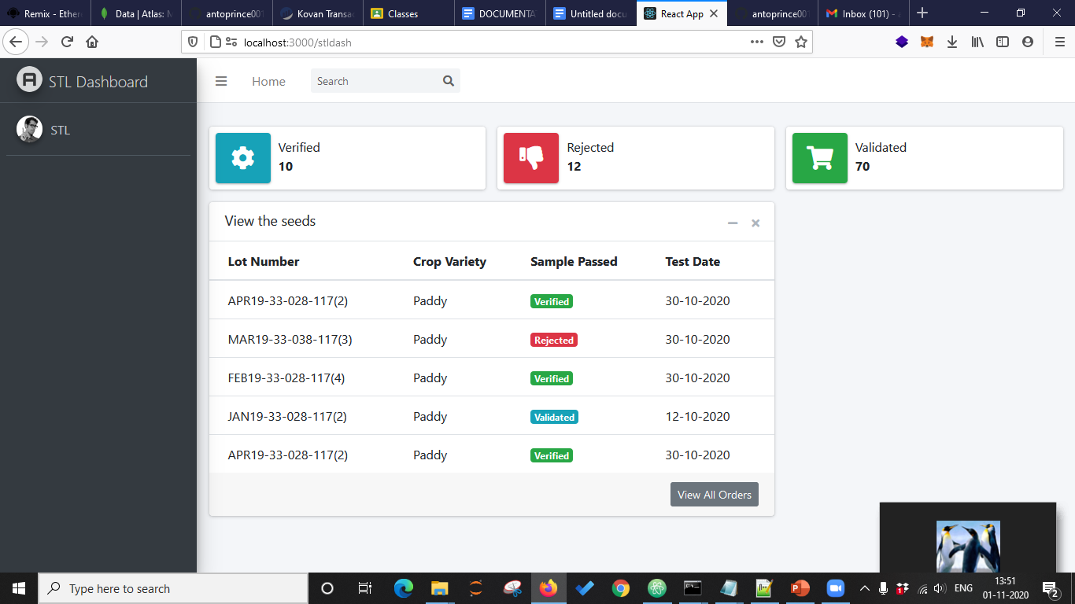

Timeline

